**ABSTRACT**

Voting is a method for a group, such as a meeting or an electorate, in order to make a collective decision or express an opinion usually following discussions, debates or election campaigns. Democracies elect holders of high office by voting. Residents of a place represented by an elected official are called "constituents", and those constituents who cast a ballot for their chosen candidate are called "voters". There are different systems for collecting votes, but while many of the systems used in decision-making can also be used as electoral systems, any which cater for proportional representation can only be used in elections.

Users can cast their vote online. Voters need to be registered before casting vote, after they are registered by the admin, they can cast their vote by entering voter id number and date of birth. Voters can see the list of nominees for the election process. Users can also provide feedback for the voting process.

##### ii

**TABLE OF CONTENTS**

##### Acknowledgement i

##### Abstract ii

##### Table of Contents iii-iv

## Chapter Particulars Page no.

##### Introduction

##### Literature Survey

##### System Requirements

##### System Design

1.1 Online Voting System 1

* 1. Introduction 3
  2. Electronic Voting 3
  3. System Analysis 5
  4. Introduction to the Database Management System 7
  5. Indicative areas for the use of a DBMS 8
  6. Advantages of a DBMS 8
  7. Components of a DBMS 9
  8. Hardware Requirements 10
  9. Software Requirements 10
  10. Schema Diagram 11
  11. ER Diagram 12
  12. Normalization 13

**iii**

## Chapter Particulars Page no.

##### Implementation

##### Snapshots

5.1 HTML5 14

5.2 JavaScript 15

* 1. SQL 16

5.4 Stored Procedure 17

5.5 Trigger 17

5.6 Function 18

6.1 Home page 19

* 1. Admin Login 19
  2. The Admin Panel 20
  3. Admin (add voter) 20
  4. Admin Password Change 21
  5. Nomination’s List 21
  6. Cast Your Vote 22
  7. Feedback 22

##### Conclusion 27

##### References 28

**iv**

## CHAPTER 1

**INTRODUCTION**

**1.1 Online Voting System**

The purpose of the application is providing an application for online voting. It provides facilities to user to cast their vote from anywhere. it allows the admin to register voters. Admin can see the numbers of votes received for each party and the final result.

Online Voting System is a web application that allow voters to cast vote from remote process. These systems can be used to minimize the cost of election. Here are the benefits of online voting system:

##### Simple & Easy to Use

The eVoting Software is simple, user-friendly, and can be easily integrated with your existing system.

##### Increased voter Engagement

Avoid frustration and tediousness by providing voters with remote access to caste vote from anywhere, anytime. Online voting system allows admin to maintain all voters.

##### Highly Secure, Scalable & Reliable

Election commission can benefit from scalable infrastructure, role-based secure access, high performance and reliable to ensure seamless access to voting application.

##### Feedback

Maximize the performance of libraries with dynamic reports, charts and graphs to review and track the progress for better decision-making.

##### Cost-effective

Embracing sophisticated technologies is cost-effective and a viable choice for government and institutions. Using mobile eliminates paper-based processes and maintenance overheads, improves productivity, reduces operation costs and saves time.

##### Mobile Access

The Online voting system provides mobile user to caste vote and resources from anywhere, at any given time via smartphones and tablets.

## CHAPTER 2

**LITERATURE SURVEY**

**2.1 INTRODUCTION**

To offer an online election system, it was necessary to study the current computerized voting system or voting machines working in different countries. Many developed countries USA, Australia have already adopted an online Election system.[11][12]

**2.2 ELECTRONIC VOTING**

Technology can include punched cards, optical scan voting systems and specialized voting kiosks (including self‐contained direct‐recording electronic voting systems, or DRE). It can also involve transmission of ballots and votes via telephones, private computer networks, or via the Internet.

Electronic voting helps voters to cast votes in an election through computerized equipment.

Sometimes this term is used to take votes over Internet.

**2.2.1 MACHINE COUNTING**

Machine‐readable ballot systems provide help to the voters to mark their votes on a paper card with marker and remove divots from a perforated card with a stylus or mechanical hole puncher. [1]

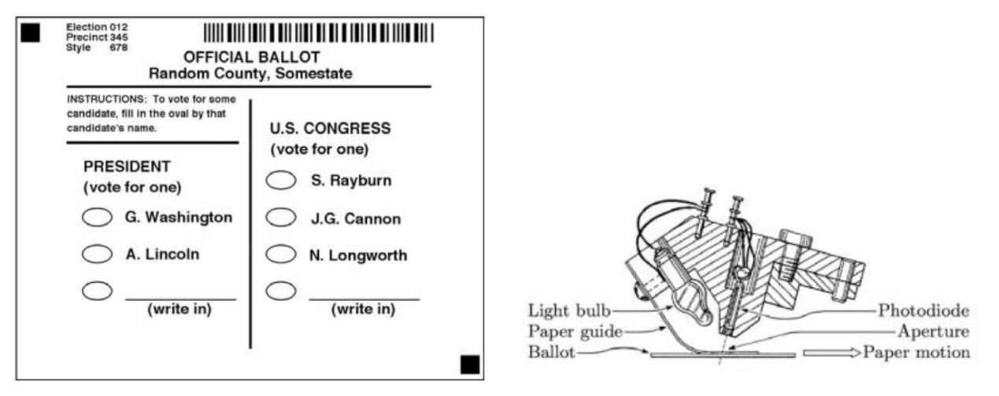

***Figure 2.2.1: Machine readable ballot paper and counting machine***

**2.2.2 COMPUTER VOTING**

Electronic voting machines (DRE) looking like an ATM’s or personal computer used to cast votes, which provides help to vote through a keyboard, a touch screen, or a pointer to mark their votes. [2]

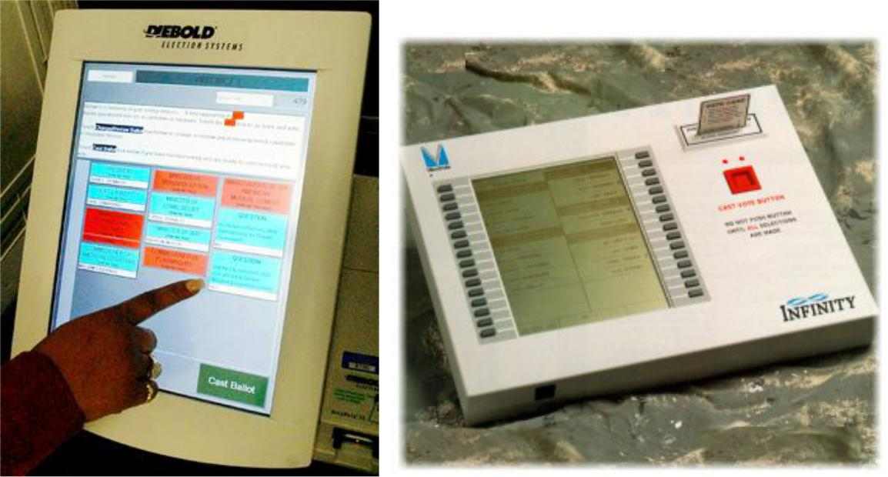

***Figure 2.2.2: Touch screen & other electronic voting machine***

**2.2.3 ONLINE VOTING**

Online voting may be conducted in a variety of ways:

1. **Poll site internetvoting systems** that require voters to go to staffed polling places and usecomputers to cast their votes. The internet is used to transfer the ballots from each polling place to centralized tallying centers.
2. **Regional poll site internetvoting systems** that allow voters to go to any poll site in aparticular city or region to cast their vote. The system keeps track of which voters have already cast their
3. ballots, and delivers the correct ballot paper to each voter based on where one resides.
4. **KIOSK internetvoting systems** that allow voters to vote from computers in KIOSKs set up bythe voting authority in convenient locations such as post offices and shopping malls. The KIOSKs are not monitored by poll workers all the time and may allow voting over a period of several days or weeks.
5. **Remotesystems that allow voters** to vote from any computer connected to the internet‐typically at home or at work. As well as via PCs, home internet voting could be through digital TV or even mobile phones or games machines. Remote internet voting might be used to replace poll site voting entirely, or it might be used only for absentee balloting. [2]

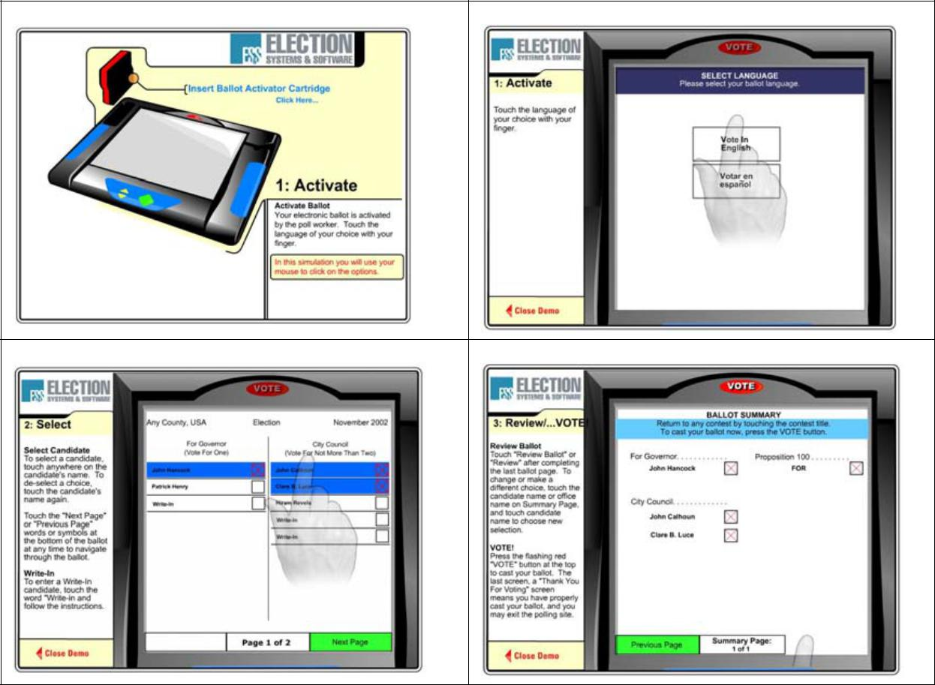

***Figure 2.2.3: Steps to cast a vote in voting machine***

The dramatic impact of the internet has led to discussions about the relation between e‐democracy and online voting. Some early enthusiasts declared that the internet could replace representative democracy, enabling everyone to vote on everything and anything at the push of a button [6]. Such visions

oversimplify the democratic process. Others have argued that e‐voting could reduce costs and increase turnout by making voting more convenient [8].

**2.3 SYSTEM ANALYSIS**

**2.3.1 EXISTING SYSTEM**

In the present system there are no such application-level system provisions in the country to carry out the voting and procedure as a whole. Also, in the present status, there is no such application in use for automated system for voting according to the voting structure existing in the country. All the step-by-step procedures are carried out by the authorized authorities according to the jobs assigned by the ECI. The fact is all the procedures are carried out manually, starting from the registration process to result publishing.

The government to do this process manually wastes a lot of time and money. Thus, the present system proves itself to be an inefficient one. The existing system is not web based. The user or person must want to go to the polling station for casting their votes.

**2.3.1.1 DRAWBACKS IN EXISTING SYSTEM**

The problems of the existing manual system of voting include among others the following:

1. **Expensive and Time consuming**: The process of collecting data and entering this data into the database takes too much time and is expensive to conduct, for example, time and money is spent in printing data capture forms, in preparing registration stations together with human resources, and there after advertising the days set for registration process including sensitizing voters on the need for registration, as well as time spent on entering this data to the database.
2. Too much paper work: The process involves too much paper work and paper storage which is difficult as papers become bulky with the population size.
3. Errors during data entry: Errors are part of all human beings; it is very unlikely for humans to be 100 percent efficient in data entry.
4. Loss of registration forms: Some times, registration forms get lost after being filled in with voters’ details, in most cases these are difficult to follow-up and therefore many remain unregistered even though they are voting age nationals and interested in exercising their right to vote.
5. Short time provided to view the voter register: This is a very big problem since not all people have free time during the given short period of time to check and update the voter register. Above all, a number of voters end up being locked out from voting.

**2.3.2 PROPOSED SYSTEM**

The new implemented voting protocol has two main players: The voter and administrator sections. The voter (which can be found at home, in a working station, in a special polling station or any other device have the function of performing the Authentication and voting). The administrator performs the function of voter and candidate registration, authorization and validation of voter, database and counting and the result.

The main advantages of the new protocol are the following:

1. Public transparency by the administrator (publication of Voter ID key, etc.).
2. Inured to technical troubles like interruption of access, etc., uncomplicated recovery.
3. Possibility of configuration for different voting models by policies and Greater performance.

Furthermore, it is assumed that a trust worthy administrator is available. Apart from that, the accessibility to the public in the voting procedure plays a special role, which means that the voting result can be monitored, although casting of the votes has to be secret as a matter of course.

Accessibility to the public is necessary for all voting stages and is performed by the electoral committee, but also by any member of the public.

**2.4 Introduction to the Database Management System**

A database management system (DBMS) refers to the technology for creating and managing databases. Basically, a DBMS is a software tool to organize (create, retrieve, update and manage) data in a database.

The main aim of a DBMS is to supply a way to store and retrieve database information that is both convenient and efficient. By data, we mean known facts that can be recorded and that have embedded meaning. Normally people use software such as DBASE IV or V, Microsoft Access or EXCEL to store data in the form of database. A datum is a unit of data. Meaningful data combines to form information. Hence, information is interpreted data-data provided with semantics. MS ACCESS is one of the most common examples of database management software.

Database systems are meant to handle large collection of information. Management of data involves both defining structures for storage of information and providing mechanisms that can do the manipulation of those stored information. Moreover, the database system must ensure the safety of the information stored, despite system crashes or attempts at unauthorized access.

**2.5 Indicative areas for the use of a DBMS**

* + - Airlines: reservations, schedules etc.
    - Telecom: calls made, customer details, network usage etc.
    - Universities: registration, results, grades etc.
    - Sales: products, purchases, customers etc.
    - Banking: all transactions etc.

**2.6 Advantages of a DBMS**

A Database Management System has many advantages over the traditional file system used in the earlier days, such as:

* + - **Data independence:** Application programs should be as free or independent as

possible from details of data representation and storage. DBMS can supply an abstract view of the data for insulating application code from such facts.

* + - **Efficient data access:** DBMS utilizes a mixture of sophisticated concepts and techniques for storing and retrieving data competently and this feature becomes important in cases where the data is stored on external storage devices.
    - **Data integrity and security:** If data is accessed through the DBMS, the DBMS can enforce integrity constraints on the data.
    - **Data administration:** Experienced professionals understand the nature of the data being managed and can be responsible for organizing the data representation to reduce redundancy and make the data to retrieve efficiently.

**2.7 Components of a DBMS**

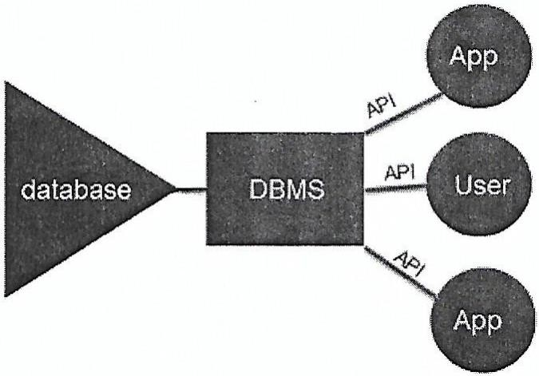

**Fig 2.7 Components of a DBMS**

* + - **Users:** Users may be of any kind, such as database administrators, system developers or database users.
    - **Database application**: Database application may be Departmental, Personal, Organizational and/or Internal**.**
    - **DBMS:** Software that allows users to create and manipulate database access.
    - **Database:** Collection of logical data as a single unit.

**SYSTEM REQUIREMENTS**

* 1. **Hardware Requirements**
     + Processor: Pentium IV or above
     + RAM — 2 GB or more
     + Hard Disk — 2GB or more
  2. **Software Requirements**

Technologies used:

* + - Front End: HTML, JAVASCRIPT, CSS, PHP
    - Connection/Controller: PHP
    - Back-End/Database: MySQL Software:
    - Text Editor: Sublime Text
    - Server: Apache (on XAMPP 7)
    - Operating System: Windows 10
    - Database Support: MySQL 5. 7

**CHAPTER 4**

**SYSTEM DESIGN**

* 1. **Schema Diagram**

A database schema is the skeleton structure that represents the logical view of the entire database. It defines how the data is organized and how the relations among them are associated. It formulates all the constraints that are to be applied on the data.

A database schema defines its entities and the relationship among them. It contains a descriptive detail of the database, which can be depicted by means of schema diagrams. It’s the database designers who design the schema to help programmers understand the database and make it useful.

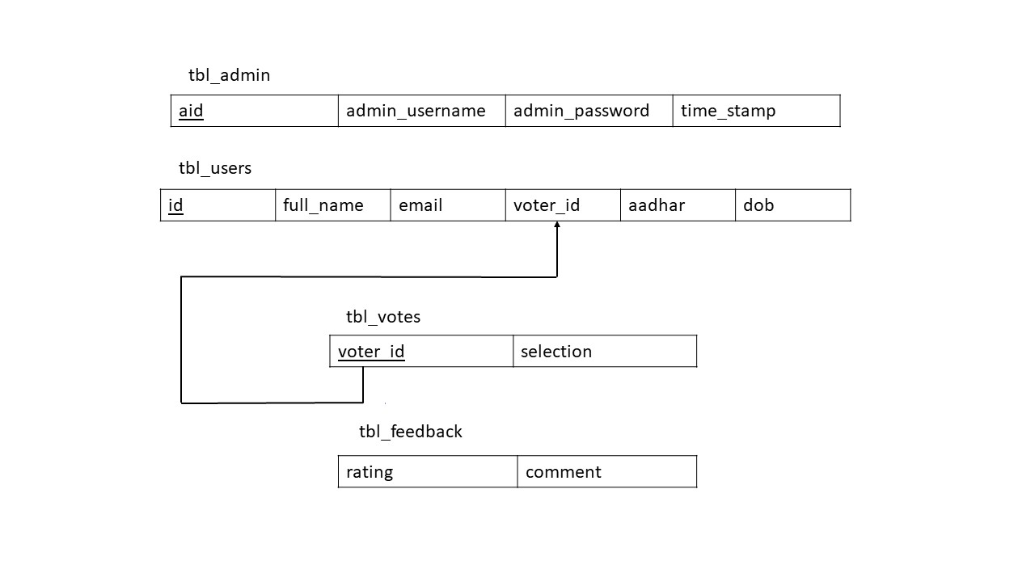

**Fig 4.1 Schema Diagram**

* 1. **ER Diagram**

An **Entity–relationship model (ER model)** describes the structure of a database with the help of a diagram, which is known as **Entity Relationship Diagram (ER Diagram).** An ER model is a design or blueprint of a database that can later be implemented as a database. The main components of E-R model are: entity set and relationship set.

An ER diagram shows the relationship among entity sets. An entity set is a group of similar entities and these entities can have attributes. In terms of DBMS, an entity is a table or attribute of a table in database, so by showing relationship among tables and their attributes, ER diagram shows the complete logical structure of a database.

.

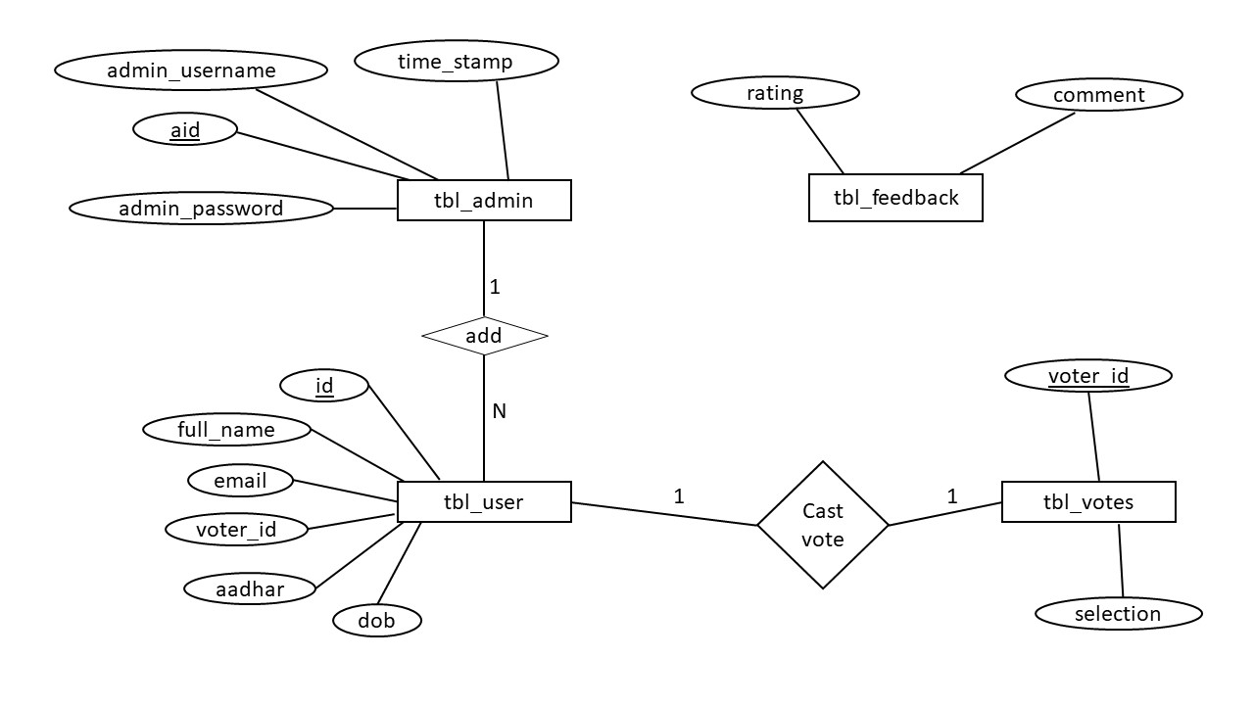

**Fig 4.2 ER Diagram**

* 1. **Normalization**

Normalizing tables accordingly based on the normal forms.

**Normal forms:** Of a relation refers to the highest normal form condition that it meets and hence indicates the degree to which it has been normalized.

* + - **First NF:** States that the domain of the attribute must only include atomic values and the value of any attribute in a tuple must be a single value.
    - **Second NF:** Is based on the concept of full functional dependency i.e., if removal of any attribute A from X in FD X->Y the dependency does not hold anymore.
    - **Third NF:** A relation schema R is in 3NF if, whenever a non-trivial functional dependency X->A holds in R either: X is a super key of R or A is prime attribute of R.
    - **Boyce-Codd NF:** A relation schema R is in BCNF if whenever a non-trivial functional dependency X->A holds in R, then X is a super key of R.
    - **Fourth NF:** A relation schema R is in 4NF w.r.t a set of dependencies F if, for every non-trivial multivalued dependency X->>Y in F+, X is a super key for R.

## CHAPTER 5

**IMPLEMENTATION**

# HTML5

**HTML5** is a markup language used for structuring and presenting content on the World Wide Web. It is the fifth and current major version of the HTML standard.

It was published in October 2014 by the World Wide Web Consortium (W3C) to improve the language with support for the latest multimedia, while keeping it both easily readable by humans and consistently understood by computers and devices such as web browsers, parsers, etc. HTML5 is intended to subsume not only HTML 4, but also XHTML 1 and DOM Level 2 HTML.

HTML5 includes detailed processing models to encourage more interoperable implementations; it extends, improves and rationalizes the markup available for documents, and introduces markup and application programming interfaces (APIs) for complex web applications. For the same reasons, HTML5 is also a candidate for cross-platform mobile applications, because it includes features designed with low-powered devices in mind.

# JavaScript

JavaScript often abbreviated as JS, is a high-level, dynamic, weakly typed, prototype-based, multi-paradigm, and interpreted programming language. Alongside HTML and CSS, JavaScript is one of the three core technologies of World Wide Web content production. It is used to make webpages interactive and provide online programs, including video games.

The majority of websites employ it, and all modern web browsers support it without the need for plug-ins by means of a built-in JavaScript engine. Each of the many JavaScript engines represent a different implementation of JavaScript, all based on the ECMA Script specification, with some engines not supporting the spec filly, and with many engines supporting additional features beyond ECMA.

As a multi-paradigm language, JavaScript supports event-driven, functional, and imperative (including object-oriented and prototype-based) programming styles. It has an API for working with text, arrays, dates, regular expressions, and basic manipulation of the DOM, but the language itself does not include any I/O, such as networking, storage, or graphics facilities relying for these upon the host environment in which it is embedded.

Initially only implemented client-side in web browsers, JavaScript engines are now embedded in many other types of host software, including server-side in web servers and databases, and in non-web programs such as word processors and PDF software, and in runtime environments that make JavaScript available for writing mobile and desktop applications, including desktop widgets.

* 1. **SQL (Structured Query Language)**

**SQL (Structured Query Language)** is a domain-specific language used in programming and designed for managing data held in a relational database management system (RDBMS), or for stream processing in a relational data stream management system (RDSMS). In comparison to older read/write APIs like ISAM or VSAM, SQL offers two main advantages: first, it introduced the concept of accessing many records with one single command; and second, it eliminates the need to specify how to reach a record, e.g., with or without an index.

Originally based upon relational algebra and tuple relational calculus, SQL consists of a data definition language, data manipulation language, and data control language. The scope of SQL includes data insert, query, update and delete, schema creation and modification, and data access control. Although SQL is often described as, and to a great extent is, a declarative language(4GL), it also includes procedural elements.

SQL was one of the first commercial languages for Edgar F Codd's relational model, as described in his influential 1970 paper, "A Relational Model of Data for Large Shared Data Banks”. Despite not entirely adhering to the relational model as described by Codd, it became the most widely used database language.

SQL became a standard of the American National Standards Institute (ANSI) in 1986 and of the International Organization for Standardization (ISO) in 1987. Since then, the standard has been revised to include a larger set of features. Despite the existence of such standards, most SQL code is not completely portable among different database systems without adjustments.

# Stored Procedure

This procedure is implemented to display user full name store in user table which is DELIMITER $$

Procedures

CREATE DEFINER=`root`@`localhost` PROCEDURE `GetAllVoters` () BEGIN

SELECT full_name FROM `tbl_users`;

END$$

# Trigger

This procedure is implemented on the INSERT and UPDATE operation. Whenever a new user add by admin , his name would be saved in the database in block letters even if the admin had entered it in small letters.

Triggers `tbl_users`

DELIMITER $$

CREATE TRIGGER `frst_l_up_insert` BEFORE INSERT ON `tbl_users` FOR EACH ROW SET NEW.full_name = capitalize(NEW.full_name)

$$

DELIMITER ;

DELIMITER $$

CREATE TRIGGER `frst_l_up_update` BEFORE UPDATE ON `tbl_users` FOR EACH ROW SET NEW.full_name = capitalize(NEW.full_name)

$$

DELIMITER ;

# Function

Capitalize Function use to capitalize first letter of word.

CREATE DEFINER=`root`@`localhost` FUNCTION `capitalize`

(`s` VARCHAR(255)) RETURNS VARCHAR(255) CHARSET utf8mb4 BEGIN

declare c int;

declare y varchar(255);

declare z varchar(255);

set x = UPPER( SUBSTRING( s, 1, 1));

set y = SUBSTR( s, 2);

set c = instr( y, ' ');

while c > 0

do

set z = SUBSTR( y, 1, c);

set x = CONCAT( x, z);

set z = UPPER( SUBSTR( y, c+1, 1));

set x = CONCAT( x, z);

set y = SUBSTR( y, c+2);

set c = INSTR( y, ' ');

end while;

set x = CONCAT(x, y);

return x;

END$$

DELIMITER ;

## CHAPTER 6

**SNAPSHOTS**

# 6.1 Home Page

This is home page contain all links like features, feedback, about, admin panel, cast your vote.

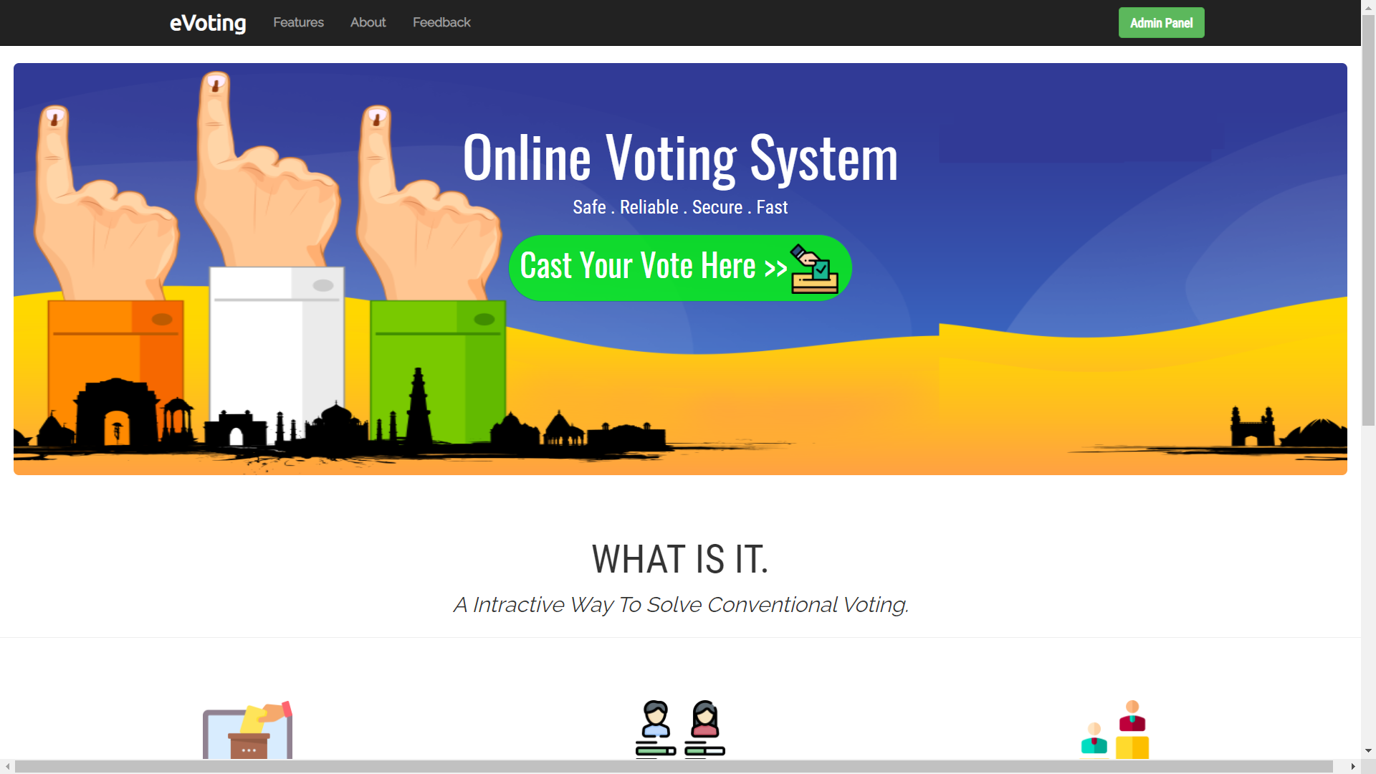

**Fig 6.1 Home Page**

# 6.2 Admin login

Here, admin login by enter username and password.

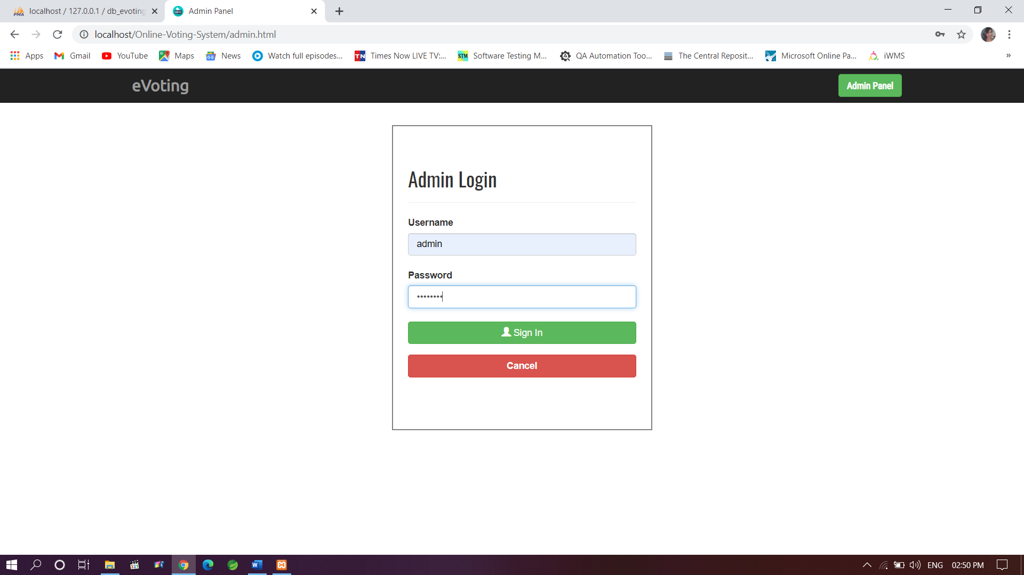

**Fig 6.2 Admin login Page**

# The Admin Panel

This is admin panel, here admin can add new user/voter, change admin password and sign out.

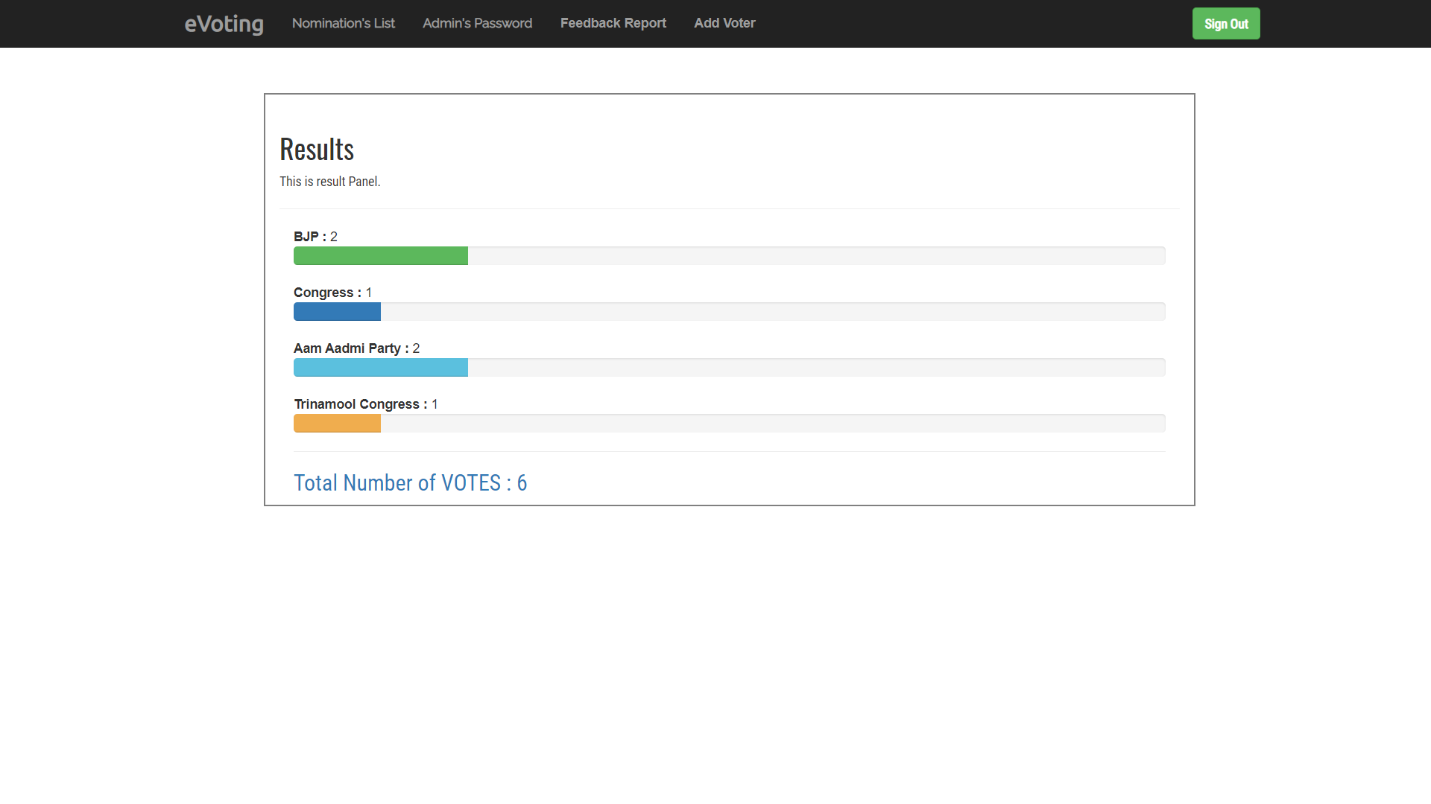

**Fig 6.3 admin panel**

# 6.4 Admin (add voter)

Here admin add new voter by basic details like, Full name, Email id, voter card number, dob, Aadhar card no.

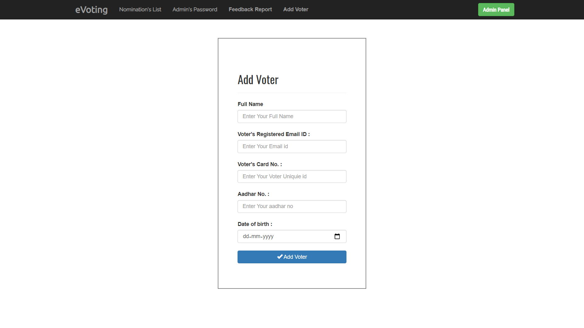

**Fig 6.4 Admin add voter**

# 6.5 Admin Password Change

Here admin can change his password here.

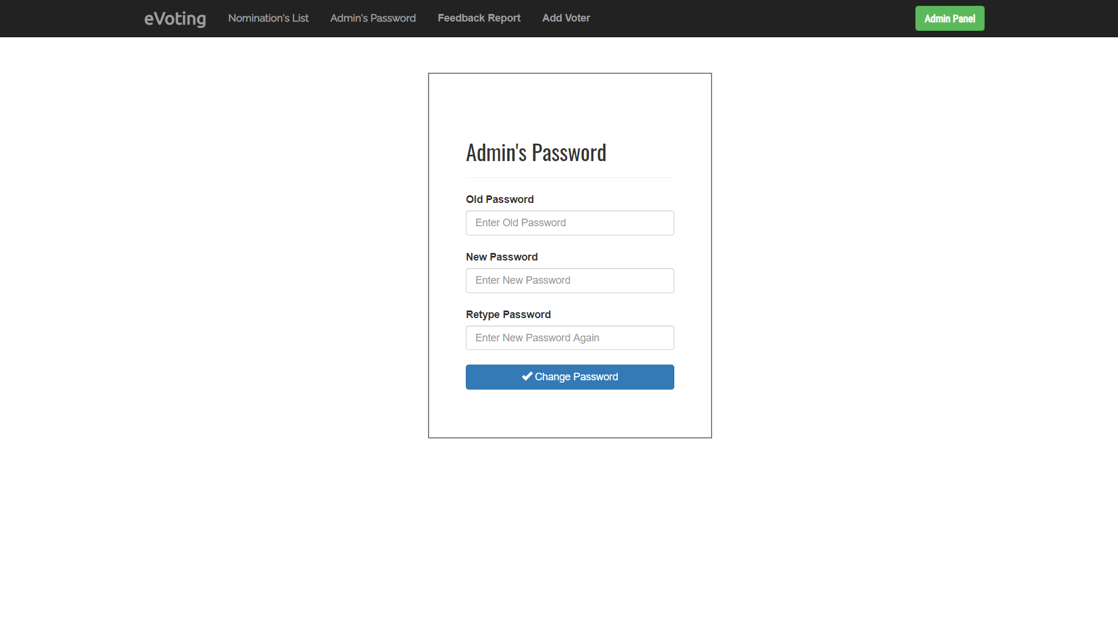

**Fig 6.5 Admin change password Page**

# 6.6 Nomination’s List

Here we can see list of candidates



Fig 6.6 Nomination’s list

# 6.7 Cast Your Vote

Here voter can cast vote by filling voter id and date of birth.

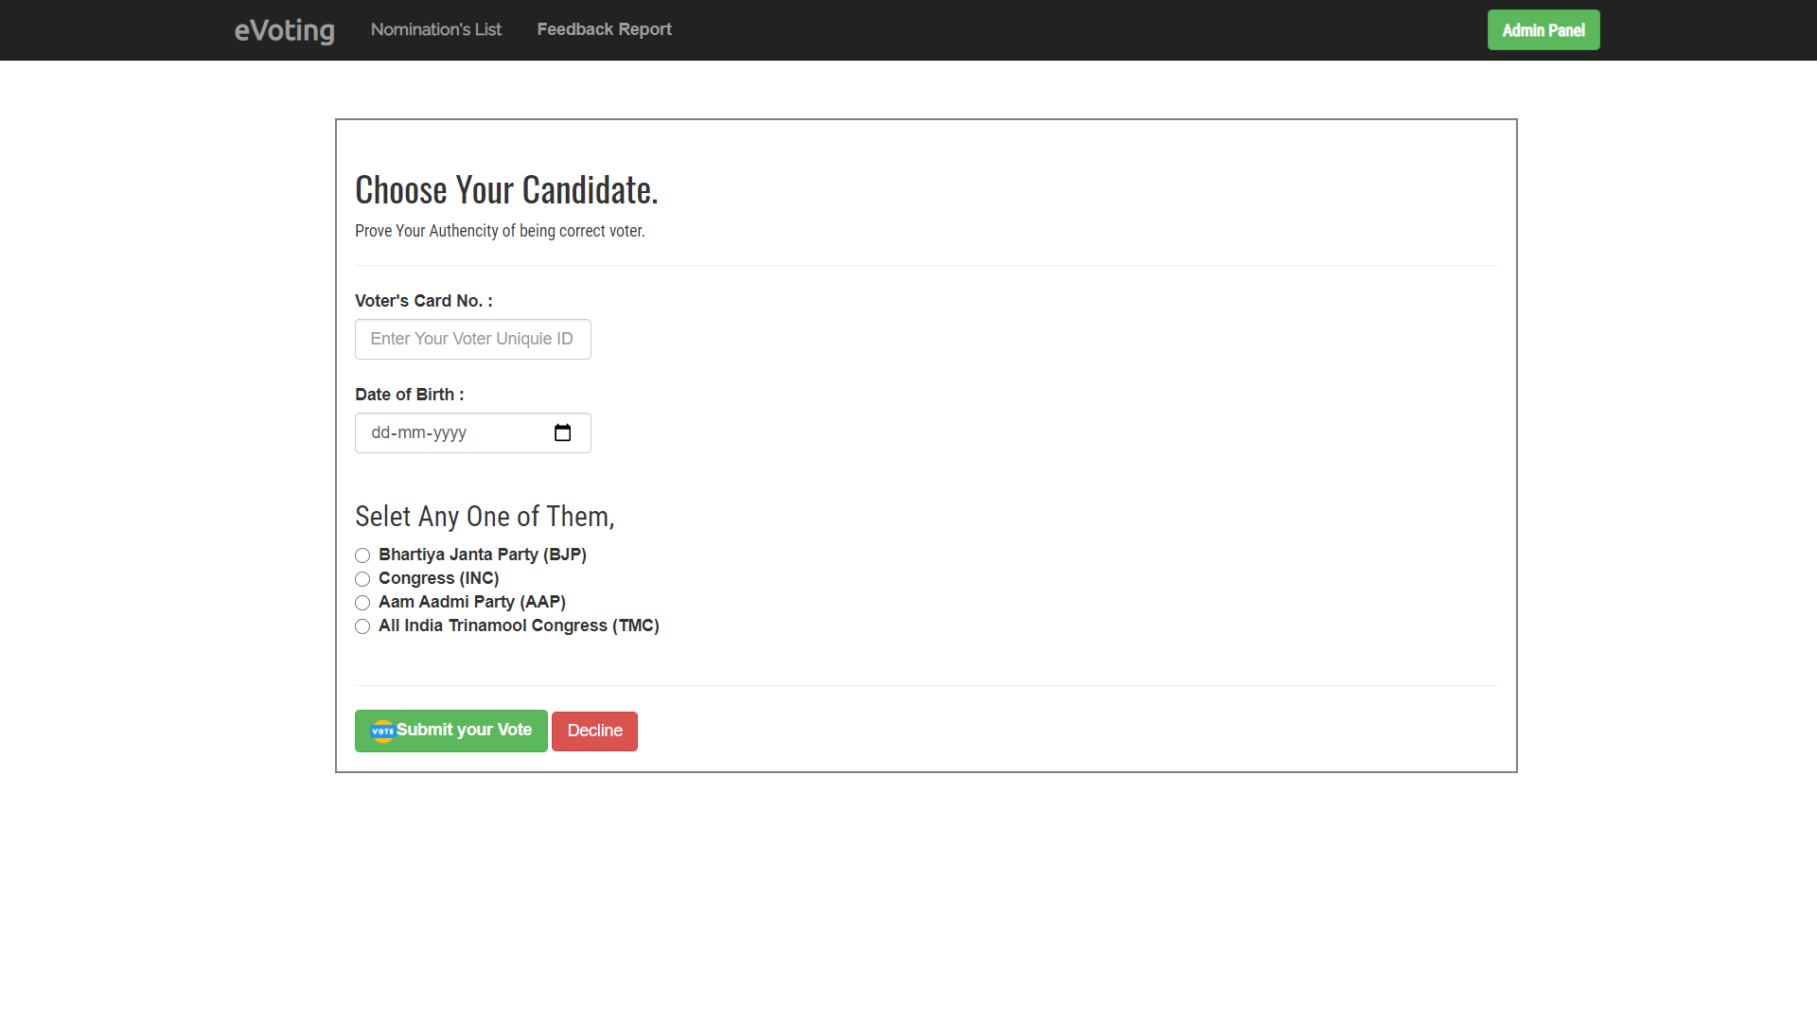

**Fig 6.7 Cast Your Vote**

# 6.8 Feedback

Here end user can give rating and feedback, and see system rating.

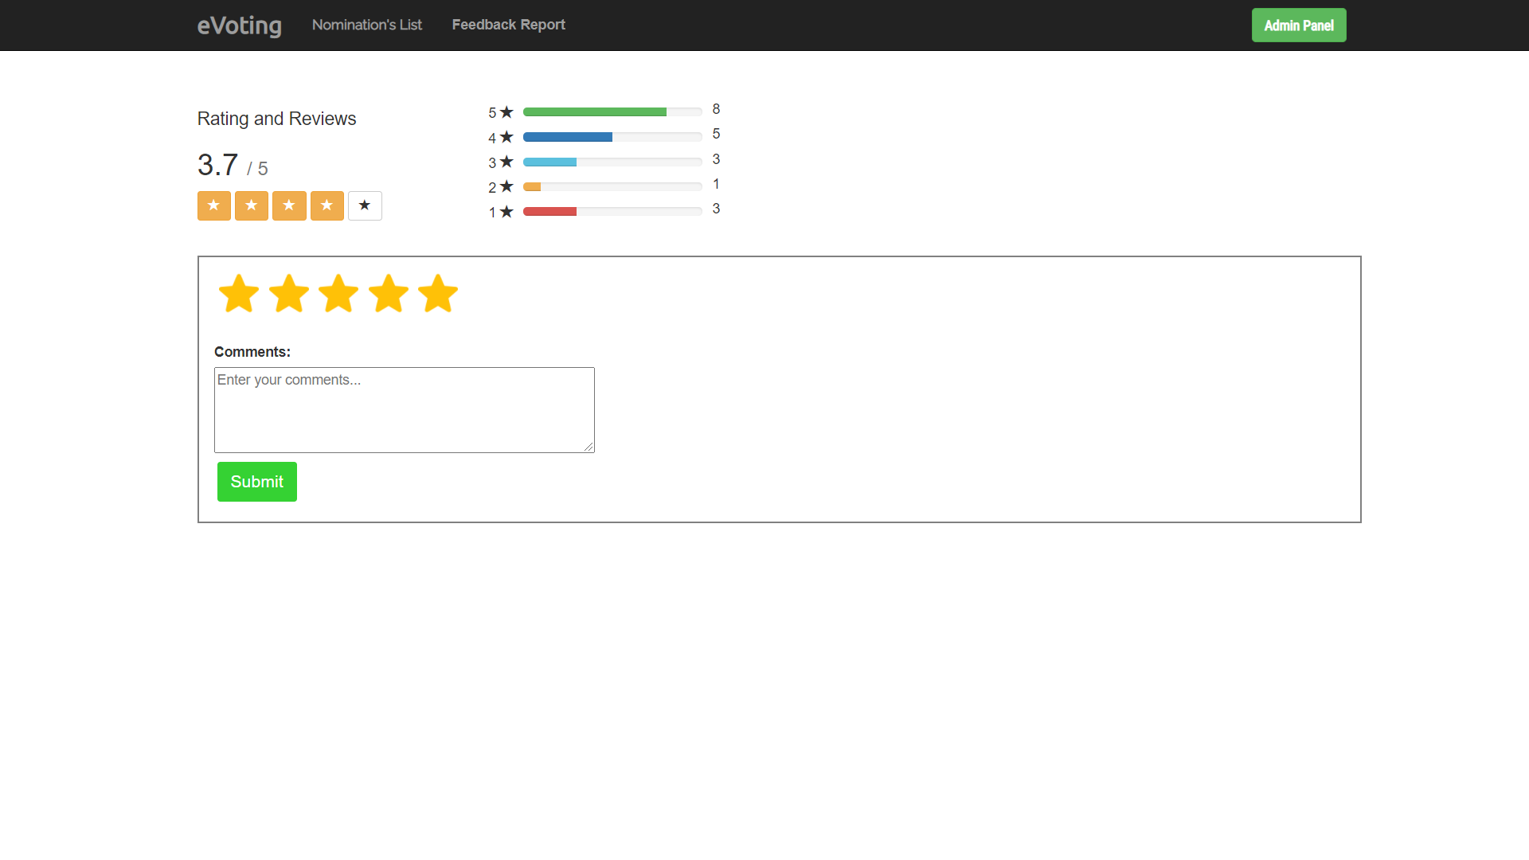

**Fig** **6.8 Feedback**

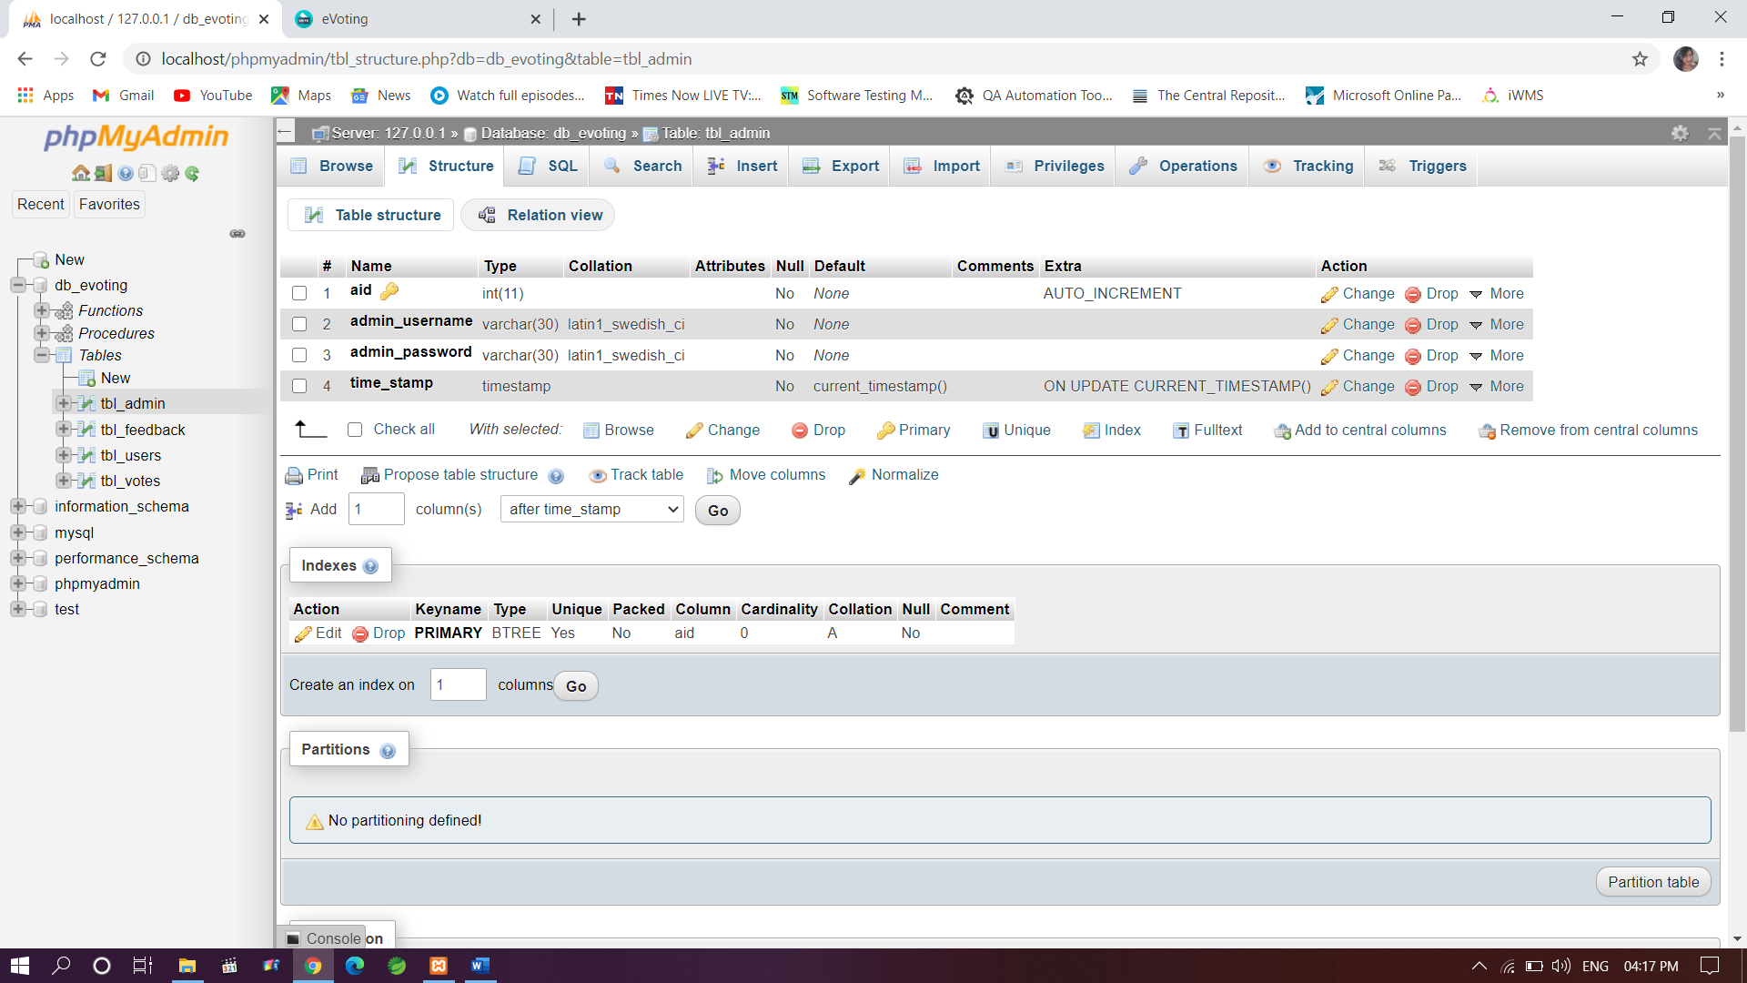

**Fig 6.9 tbl_admin**

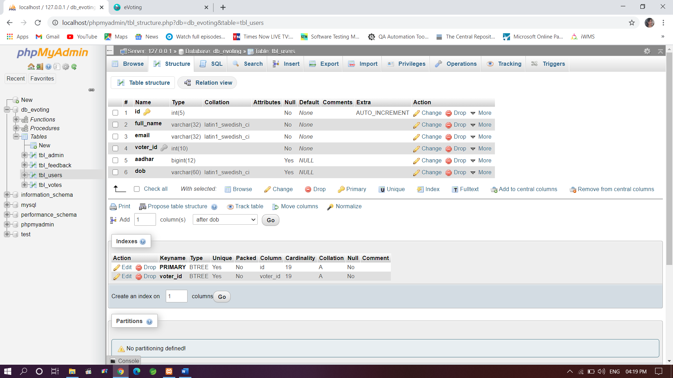

**Fig 6.8 tbl_users**

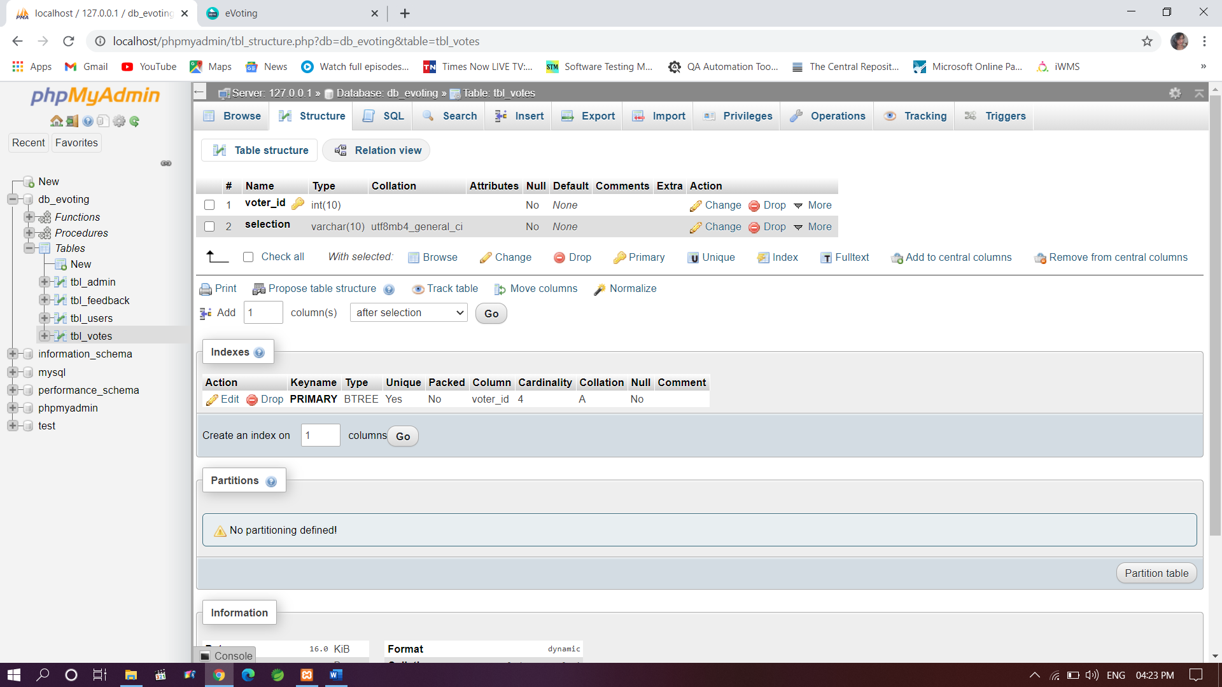

**Fig 6.9 tbl_voters**

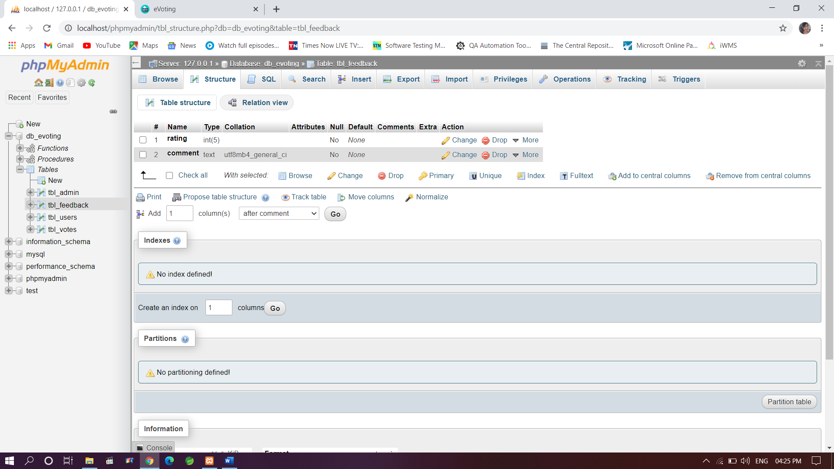

**Fig 6.10 tbl_feedback**

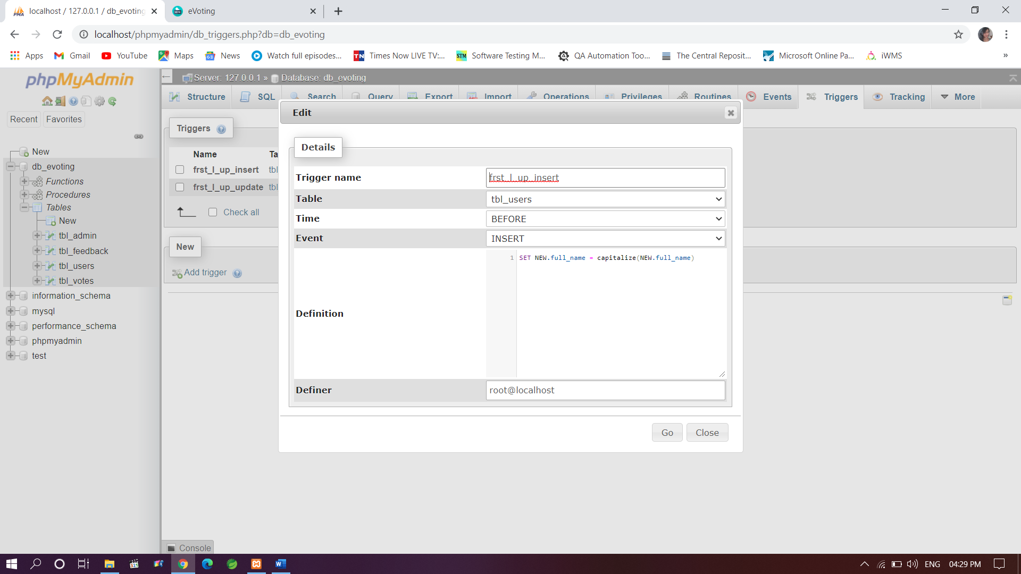

**Fig 6.11 Trigger(insert)**

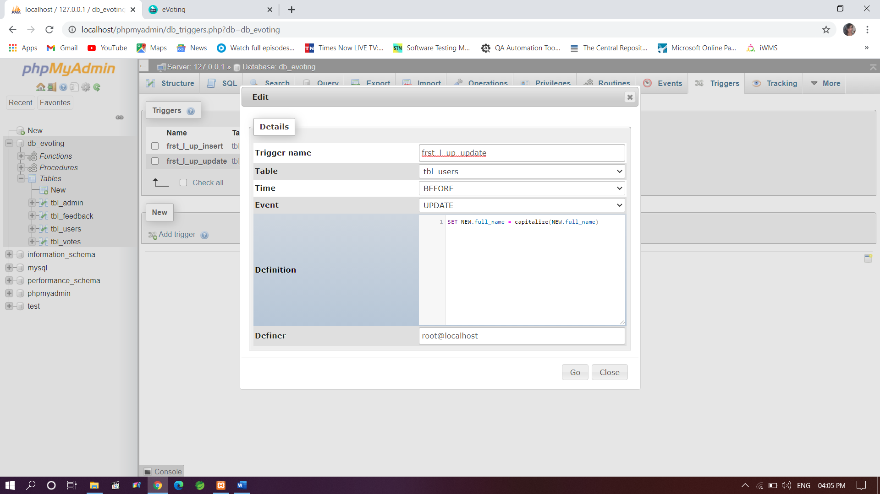

**Fig 6.12 Trigger (update)**

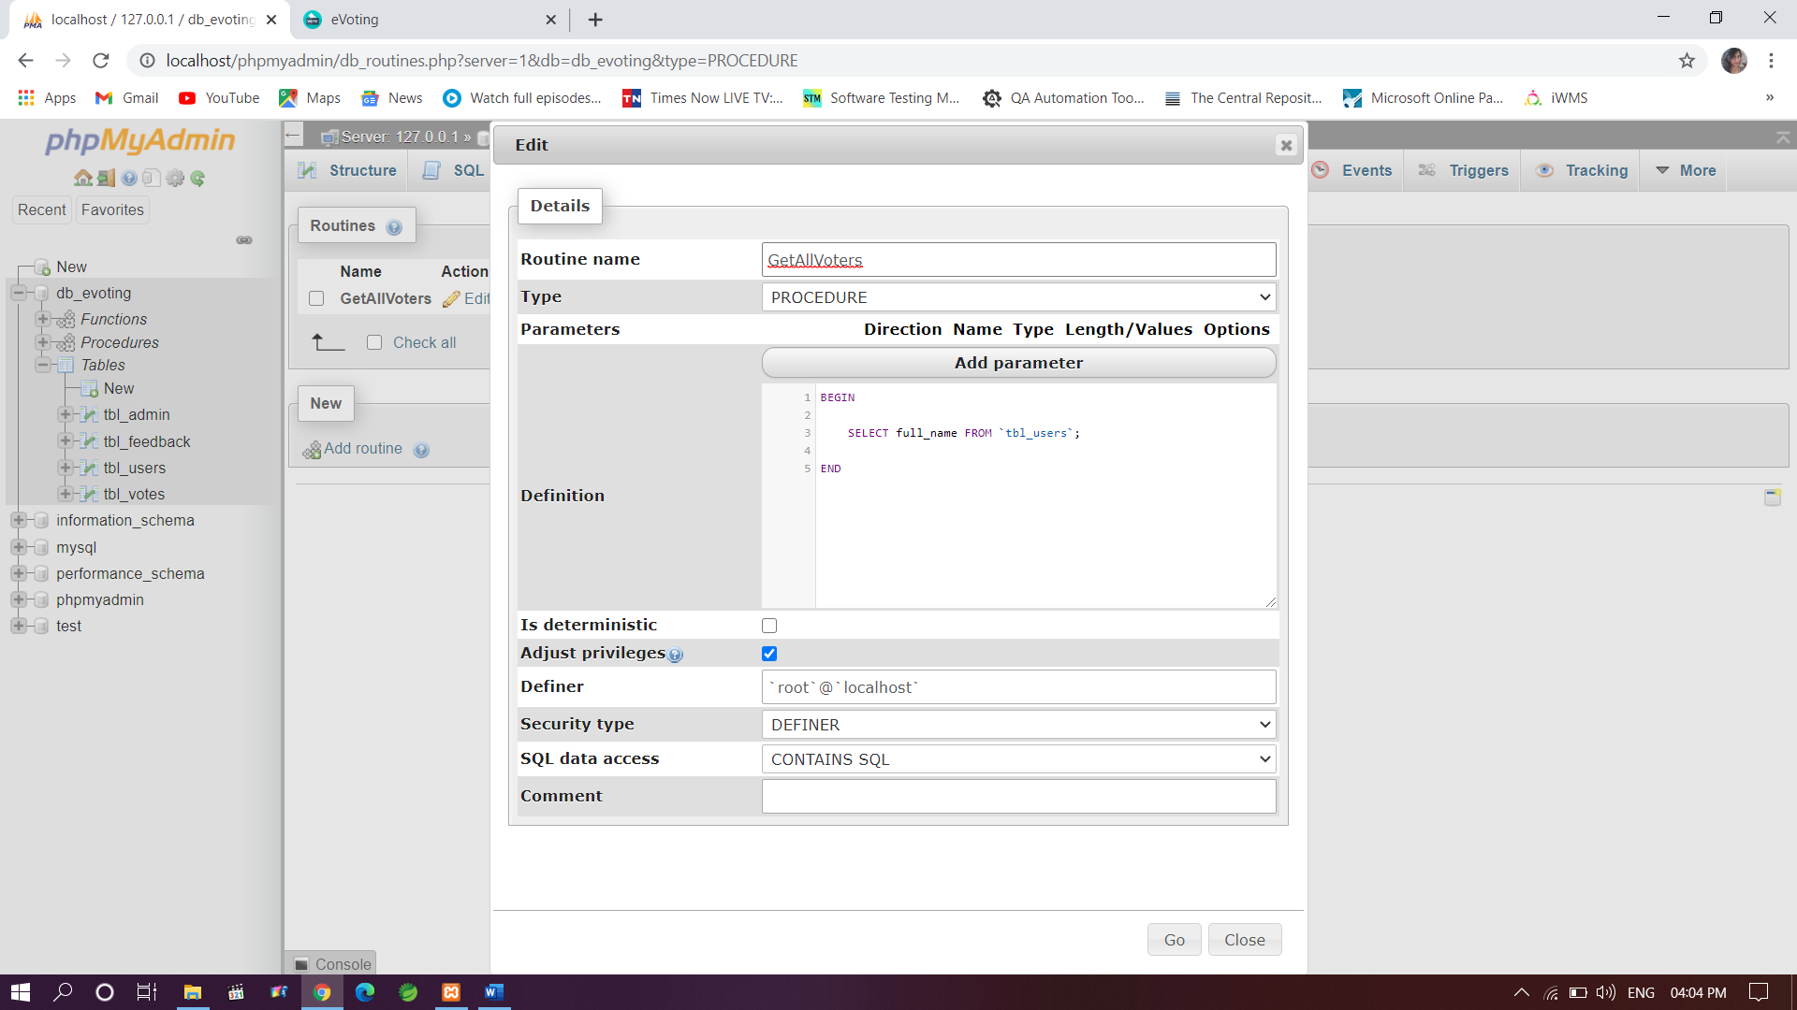

**Fig 6.13 Stored Procedure**

# CONCLUSION

With the theoretical inclination of our syllabus, it becomes very essential to take the utmost advantage of any opportunity of gaining practical experience that comes along. The construction of this mini project "Online Voting System" was one of these opportunities. It gave us the requisite practical knowledge to supplement the already taught theoretical concepts, thus making us more competent.

In the present system, voter have to be cast vote by going to the Polling Booth while Online Voting System makes it easier to cast vote from eVoting website online and is timely and user-friendly.

**REFERENCES**

* The Bootstrap Website (for design) — https://getbootstrap.com/docs/4.3/getting- started/introduction/
* W3Schools (HTML, CSS and PHP reference) — https://[www.w3schools.com/tags/default.asp](http://www.w3schools.com/tags/default.asp)
* PHP Official Documentation —<http://php.net/docs.php>
* The MySQL Documentation — https://dev.mysql.com/doc/refman/8.0/en/
* Stack Overflow —https://stackoverflow.com/questions/tagged/javascript